**Course Methods Test 3 Year 12**

Student name: ________________ Teacher name: ________________

**Task type: Response/Investigation**

**Reading time for this test : 5 mins**

**Working time allowed for this task: 40 mins**

**Number of questions: ____6_______**

**Materials required:** No classpads

Standard items: Pens (blue/black preferred), pencils (including coloured), sharpener, correction fluid/tape, eraser, ruler, highlighters

Special items: Drawing instruments, templates, notes on one unfolded sheet of   
A4 paper

**Marks available: __38____ marks**

**Task weighting: _14___%**

**Formula sheet provided: No but some formulae given on page 2**

**Note: All part questions worth more than 2 marks require working to obtain full marks.**

**Useful formulae**

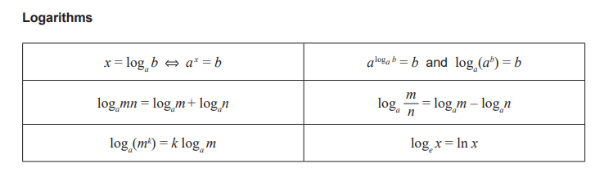

Q1 (2 & 2 = 4 marks)

Express each of the following as a single logarithm.

1. .

|  |
| --- |
| **c** |
|  |
| **Specific behaviours** |
| 🗸 uses log laws  🗸 expresses as one log statement (Do not accept 3) |

1. .

|  |
| --- |
| **c** |
|  |
| **Specific behaviours** |
| 🗸 changes 5 into a log statement  🗸 expresses as one log statement |

Q2 (2 & 2 = 4 marks)

Solve each of the following, giving your answer in exact form.

a)

|  |
| --- |
| **c** |
|  |
| **Specific behaviours** |
| 🗸 uses quadratic expression  🗸 solves for both x values |

b) 

|  |
| --- |
| **c** |
|  |
| **Specific behaviours** |
| 🗸 factorises  🗸 solves in log form |

Q3 (1, 3 & 3 = 7 marks)

The Richter scale,, of an earthquake of intensity  is given by  where  is a minimum intensity level used for comparison.

1. Determine  for an earthquake with intensity .

|  |
| --- |
| **c** |
|  |
| **Specific behaviours** |
| 🗸 states answer |

1. An earthquake measuring 5 on the Richter scale is how many times as intense as that of one measuring 4 on the Richter scale?

|  |
| --- |
| **c** |
|  |
| **Specific behaviours** |
| 🗸 converts log statement into index form  🗸 divides both intensities  🗸 states ratio (1 mark for answer only) |

1. If an earthquake registers  on the Richter scale and a second earthquake registers  on the Richter scale, how many more times as intense is the second earthquake?

|  |
| --- |
| **c** |
|  |
| **Specific behaviours** |
| 🗸 converts log statement into index form  🗸 divides both intensities  🗸 states ratio (1 mark for answer only) |

Q4 (3 marks)

Consider the function  which undergoes a transformation  where  are constants. The graph  is plotted below, determine the values of showing reasoning.

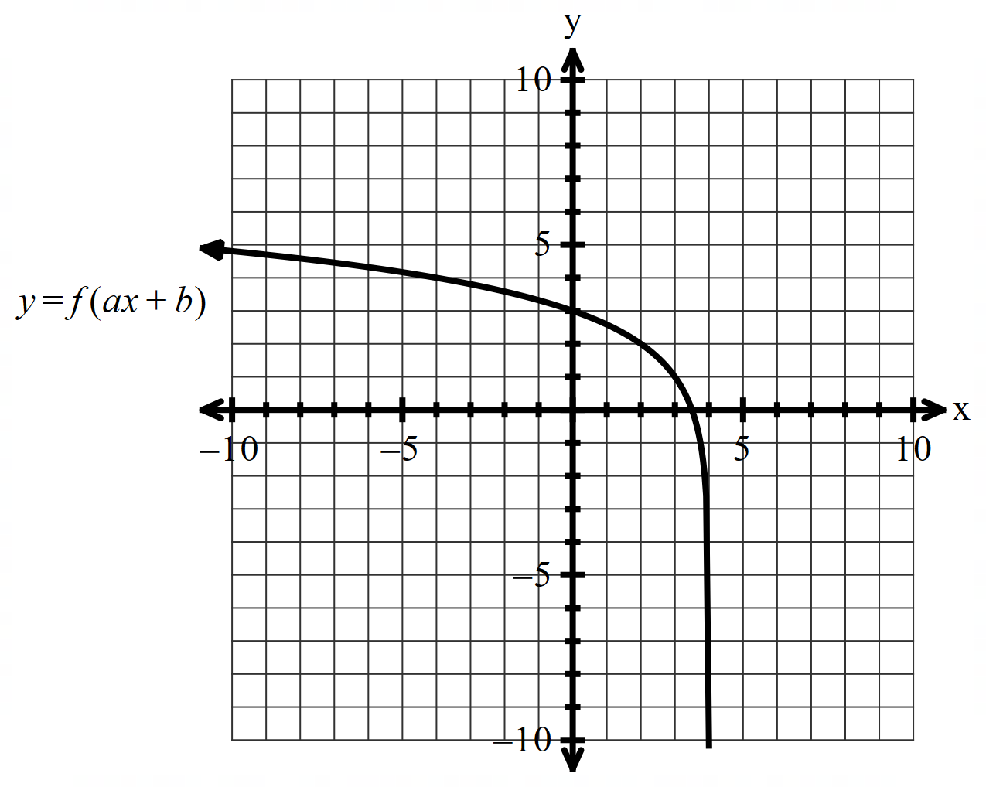

|  |
| --- |
| **c** |
|  |
| **Specific behaviours** |
| 🗸 sets up equation to solve for b  🗸 sets up equation to solve for a  🗸 states values of a & b (max 1 mark for answer only) |

Q5 (3 & 5 = 8 marks)

Consider the function .

1. Determine .(Simplify)

|  |
| --- |
| **c** |
|  |
| **Specific behaviours** |
| 🗸 uses product rule  🗸 correct derivatives  🗸 simplifies |

1. Use the result from part a to determine .

|  |
| --- |
| **c** |
|  |
| **Specific behaviours** |
| 🗸 shows the integration of all terms in derivative statement from part a  🗸 uses FTC  🗸 uses natural log in integration of one term  🗸 integrates all required terms  🗸 adds a constant at end |

Q6 (3, 3, 3 & 3 = 12 marks)

Consider the continuous random variable  and its probability density function which is graphed below.

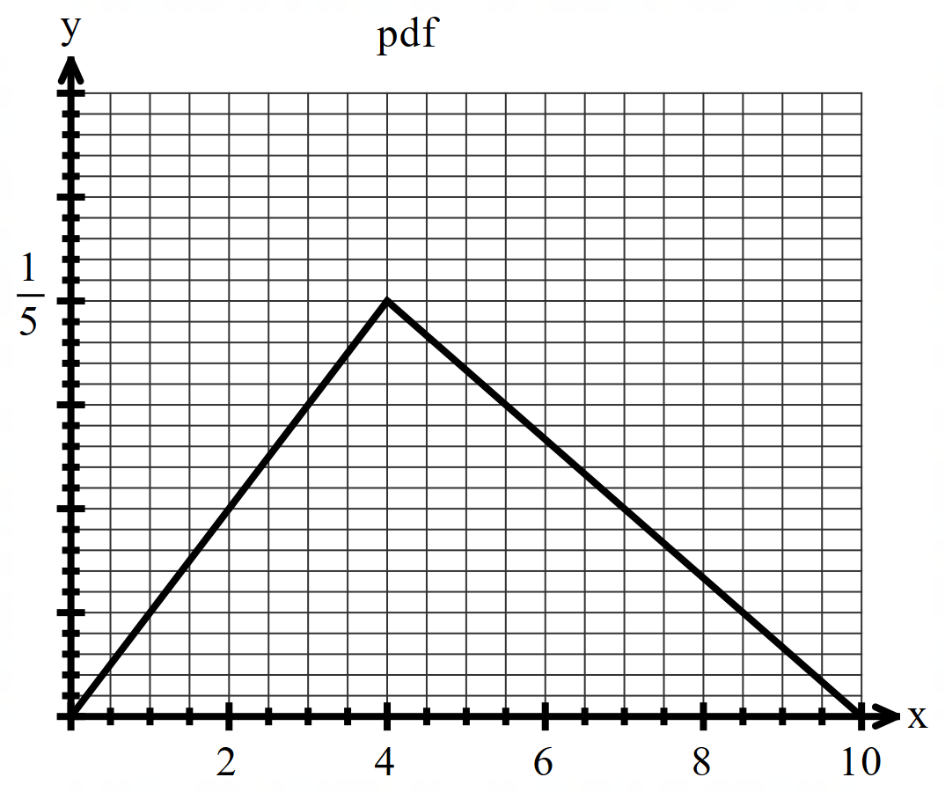

1. Determine the following exactly.
2. .(Simplify)

|  |
| --- |
| **c** |
| OR |
| **Specific behaviours** |
| 🗸 determines area from x=2 to 4 OR uses two triangles 0 to2 and 7 to 10  🗸 determines area from x=2 to x=4 OR subtracts the area of two triangles above from 1  🗸 adds to give simplified total area |

1. .(No need to simplify)

|  |
| --- |
| **c** |
| OR use triangles    Note- Height of triangle above must =  for full marks (do not accept approx.) |
| **Specific behaviours** |
| 🗸 writes a conditional prob statement (or directly implied)  🗸 evaluates denominator/area (un simplified but evaluated)  🗸 evaluates numerator/area (un simplified but evaluated) |

1. E(X) i.e the mean. (No need to simplify)

|  |
| --- |
| **c** |
|  |
| **Specific behaviours** |
| 🗸 sets up integral in two parts  🗸 evaluates one part integral without simplifying  🗸 evaluates second part integral without simplifying |

1. Derive the cumulative probability function  for .

|  |
| --- |
| **c** |
|  |
| **Specific behaviours** |
| 🗸 defines cumulative in integral form and in two parts  🗸 evaluates function for 0<x<4  🗸 evaluates function for 4<x<10, no need to simplify |

**End of test**

**Working out space**